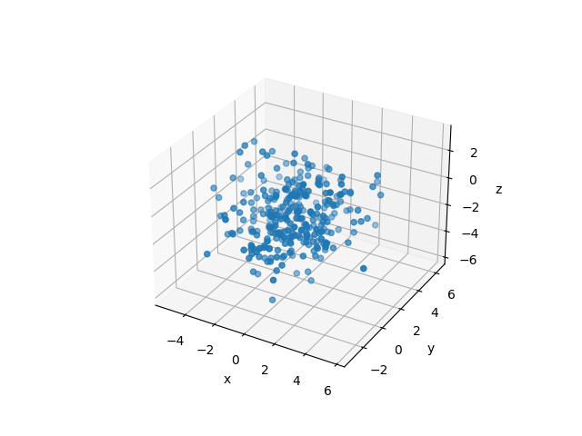**Section 1.2**

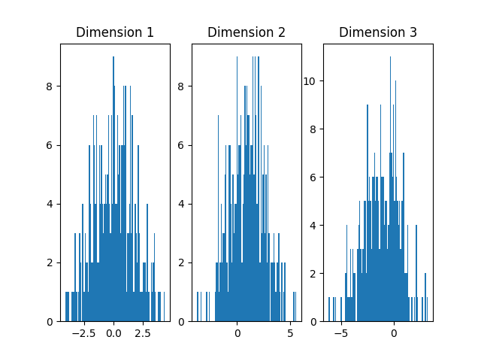**Section 1.3**

**Do you expect the batch estimate to be exactly (0,1,−1) ? Which two parameters can be used to make this estimate more accurate?**

Answer: No I did not expect it to be exactly (0,1,-1) because of the variance is quite high (squere root of 3). Obviously lowering the variance would make the estimate more accurate, also you should be able to make it more accurate with more datapoints.

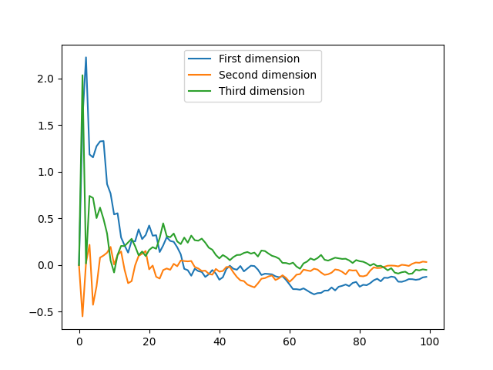**Section 1.5**

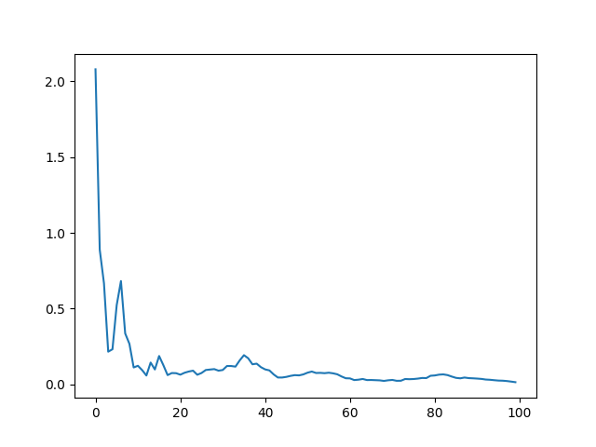

**Section 1.6**